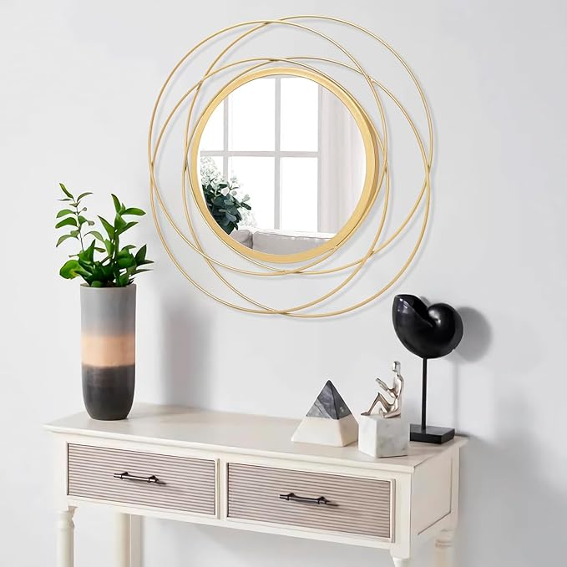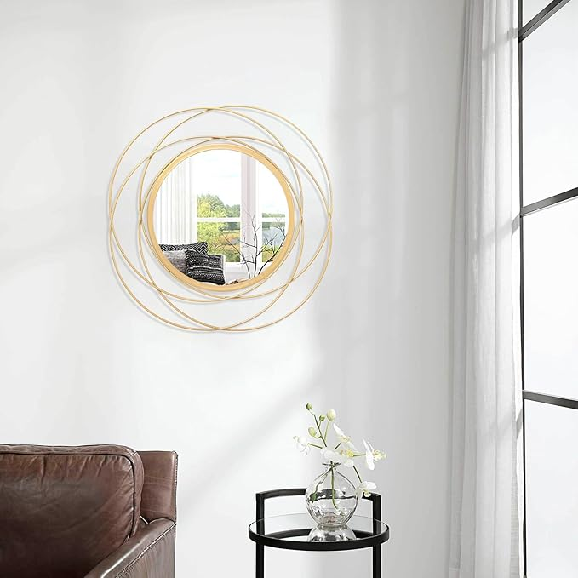

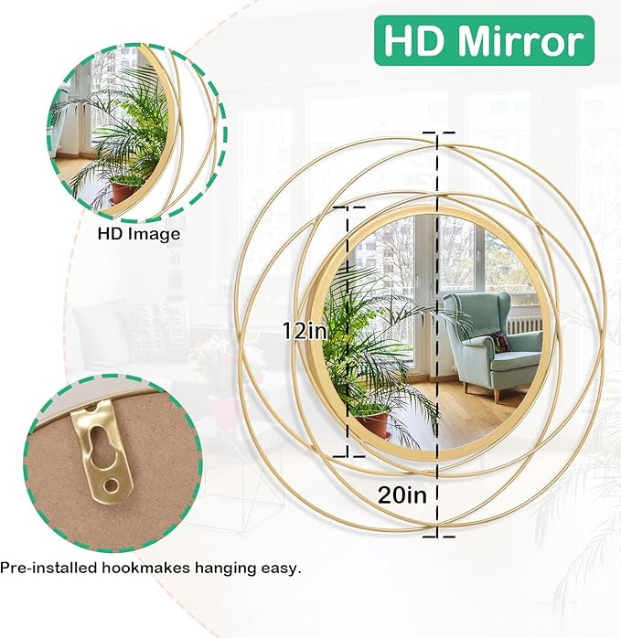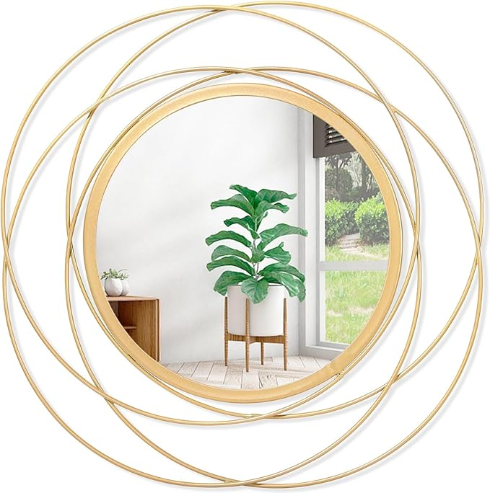

Gold Wall Mirror Mounted Round Decorative Mirrors with Iron Metal Wire Frame Mirror for Wall, Home Decorative Bathroom Vanity, Living Room or Bedroom White Small 20” x 20”

**PRODUCT DESCRIPTION:**

|  |  |
| --- | --- |
| Brand | HLFMVWE |
| Room Type | Bathroom, Bedroom, Living Room |
| Shape | Round |
| Product Dimensions | 20"L x 20"W |
| Frame Material | Iron |

**About this item**

* PERFECT SIZE : Mirror along measures 12"/16"/20"/24". Multiple sizes available. is just perfect to decorate the bedroom /living room or entryway as a boho decoration or hang them on in bathroom as functional dressing mirrors
* QUALITY AND STYLE : This stylish mirror is made up of a unique iron frame and a glass mirror with a crystal clear reflection. This classic and elegant mirror is perfect for any wall. The mirror on the wall makes it decorative as well as functional
* DURABLE IRON FRAME: This wall mirror comes with an additional locking hole mounting bracket that can be easily installed with screws (hardware not included). The iron frame makes the mirror durable, sturdy and carefully crafted for excellent quality
* SUITABLE FOR OCCASIONS : They can also go to decorate your living room, bedroom, dining room, gallery, staircase, Hallway with different shapes of round hanging mirrors, Ideal for decorating a room in an artistic
* WIDE RANGE OF APPLICATIONS: This mirror is wonderful for making a beautiful modern vanity in your bathroom or adding some light and dimension to any space in your home to make your home feel more spacious and bright